Cloud Infrastructure

☁️ What Is Cloud Infrastructure?
# Source: AI Source: Provided by: [Data Path: Persons Table -> ID Column: 1, Name_En Column: Motasem Essam] -> From: [ChatGPT] on [1/26/2026]
Cloud infrastructure refers to the virtualized computing resources—such as servers, storage, networking, and software—that are delivered over the internet by a cloud provider. Instead of owning and maintaining physical hardware, users access resources on-demand from a cloud data center.

🧠 Simple Definition:
# Source: AI Source: Provided by: [Data Path: Persons Table -> ID Column: 1, Name_En Column: Motasem Essam] -> From: [ChatGPT] on [1/26/2026]
Cloud infrastructure is a virtual IT environment provided by a third party (like AWS, Azure, or Google Cloud), where users can run applications, store data, and scale services without owning physical hardware.

🧰 Core Components of Cloud Infrastructure
# Source: AI Source: Provided by: [Data Path: Persons Table -> ID Column: 1, Name_En Column: Motasem Essam] -> From: [ChatGPT] on [1/26/2026]
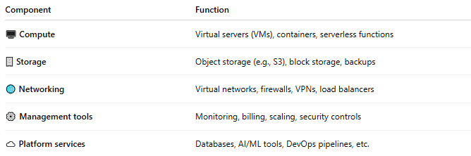

Component | Function
🖥️ Compute | Virtual servers (VMs), containers, serverless functions
🗄️ Storage | Object storage (e.g., S3), block storage, backups
🌐 Networking | Virtual networks, firewalls, VPNs, load balancers
⚙️ Management tools | Monitoring, billing, scaling, security controls
☁️ Platform services | Databases, AI/ML tools, DevOps pipelines, etc.

☁️ Cloud Infrastructure Types
# Source: AI Source: Provided by: [Data Path: Persons Table -> ID Column: 1, Name_En Column: Motasem Essam] -> From: [ChatGPT] on [1/26/2026]
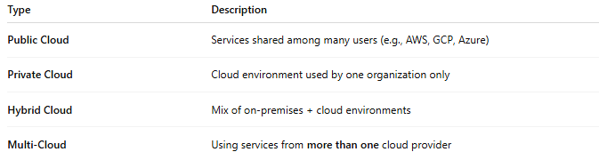

Type | Description
Public Cloud | Services shared among many users (e.g., AWS, GCP, Azure)
Private Cloud | Cloud environment used by one organization only
Hybrid Cloud | Mix of on-premises + cloud environments
Multi-Cloud | Using services from more than one cloud provider

📦 Examples of Cloud Providers
# Source: AI Source: Provided by: [Data Path: Persons Table -> ID Column: 1, Name_En Column: Motasem Essam] -> From: [ChatGPT] on [1/26/2026]
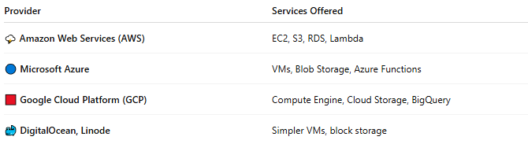

Provider | Services Offered
🌩️ Amazon Web Services (AWS) | EC2, S3, RDS, Lambda
🔵 Microsoft Azure | VMs, Blob Storage, Azure Functions
🟥 Google Cloud Platform (GCP) | Compute Engine, Cloud Storage, BigQuery
🐳 DigitalOcean, Linode | Simpler VMs, block storage

✅ Benefits of Cloud Infrastructure
# Source: AI Source: Provided by: [Data Path: Persons Table -> ID Column: 1, Name_En Column: Motasem Essam] -> From: [ChatGPT] on [1/26/2026]
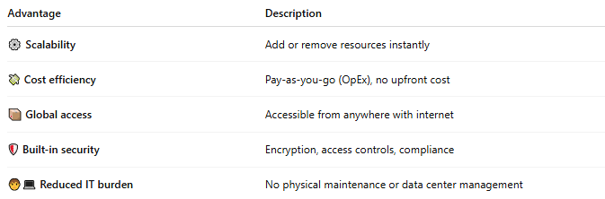

Advantage | Description
⚙️ Scalability | Add or remove resources instantly
💸 Cost efficiency | Pay-as-you-go (OpEx), no upfront cost
📦 Global access | Accessible from anywhere with internet
🛡️ Built-in security | Encryption, access controls, compliance
🧑‍💻 Reduced IT burden | No physical maintenance or data center management

⚠️ Challenges to Consider
# Source: AI Source: Provided by: [Data Path: Persons Table -> ID Column: 1, Name_En Column: Motasem Essam] -> From: [ChatGPT] on [1/26/2026]
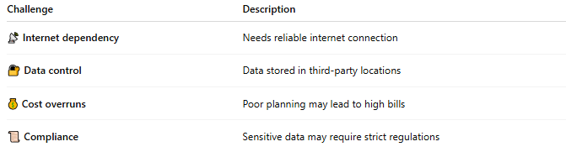

Challenge | Description
📡 Internet dependency | Needs reliable internet connection
🔐 Data control | Data stored in third-party locations
💰 Cost overruns | Poor planning may lead to high bills
📜 Compliance | Sensitive data may require strict regulations

🆚 On-Premises vs Cloud Infrastructure
# Source: AI Source: Provided by: [Data Path: Persons Table -> ID Column: 1, Name_En Column: Motasem Essam] -> From: [ChatGPT] on [1/26/2026]
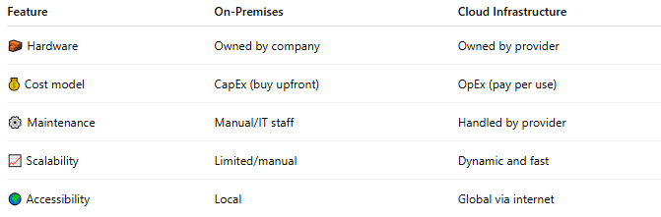

Feature | On-Premises | Cloud Infrastructure
🧱 Hardware | Owned by company | Owned by provider
💰 Cost model | CapEx (buy upfront) | OpEx (pay per use)
⚙️ Maintenance | Manual/IT staff | Handled by provider
📈 Scalability | Limited/manual | Dynamic and fast
🌍 Accessibility | Local | Global via internet

📌 Summary
# Source: AI Source: Provided by: [Data Path: Persons Table -> ID Column: 1, Name_En Column: Motasem Essam] -> From: [ChatGPT] on [1/26/2026]
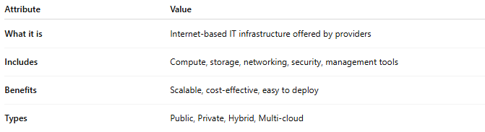

Attribute | Value
What it is | Internet-based IT infrastructure offered by providers
Includes | Compute, storage, networking, security, management tools
Benefits | Scalable, cost-effective, easy to deploy
Types | Public, Private, Hybrid, Multi-cloud

